**Module13 Assignment8**

**Understanding the role of break, continue, and pass in Python loops**

In Python, the break, continue, and pass statements are used to control the flow of loops (for and while) in specific ways. Here's an explanation of each one:

**1. break**

The break statement is used to **exit** the loop completely, even if the loop condition is still true. When break is encountered, the loop stops and the program continues to the next line of code after the loop.

Example:

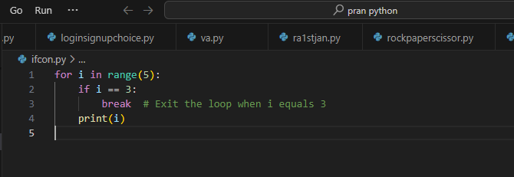

Output:

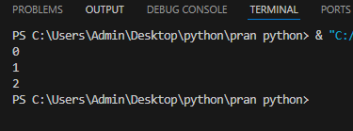

### 2. continue

The continue statement is used to **skip** the current iteration of the loop and move to the next iteration. The rest of the code in the loop after continue is skipped for that iteration.

Example:

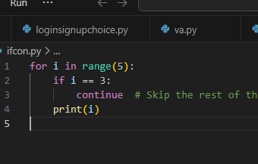

Output:

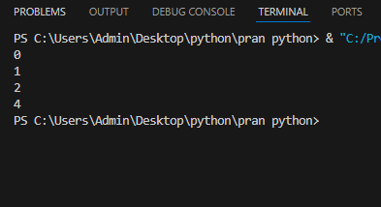

### 3. pass

The pass statement does nothing. It's a placeholder and can be used when a statement is syntactically required but you don't want to perform any action. It doesn't affect the loop's flow like break or continue, but it's useful for scenarios where you need to write syntactically valid code without doing anything.

Example:

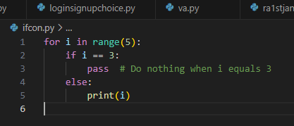

Output:

